Selenium Practice
Basic selenium and getting title
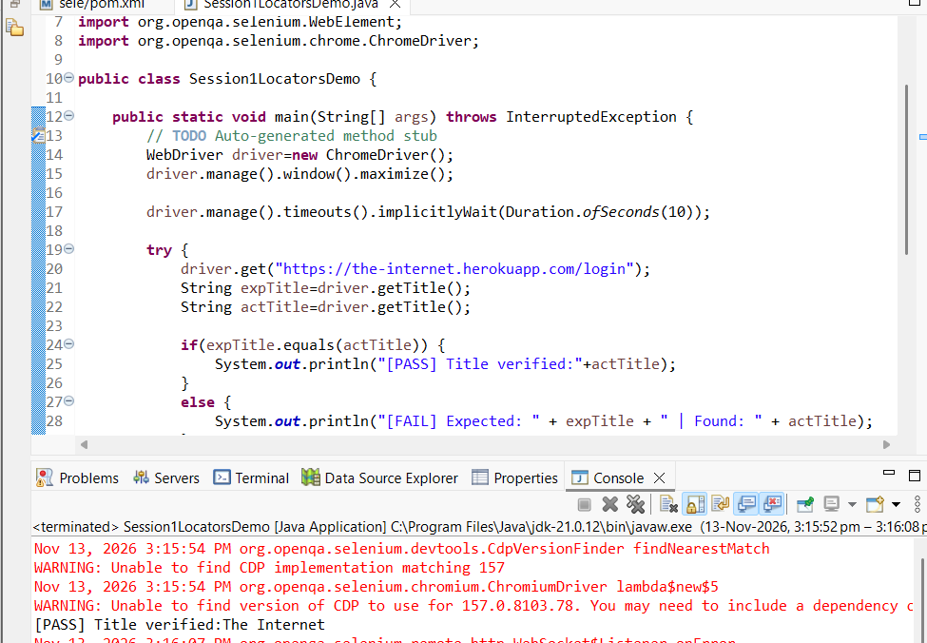

XPATH
Breakdown of //div[@id='flash']
- // (Double Slash): Searches anywhere in the DOM (Document Object Model), regardless of how deeply nested the element is. This creates a relative XPath.
- div (Tag Name): Specifies the HTML element tag to match. Use * as a wildcard if you want to match any tag (e.g., //*[@id='flash']).
- [...] (Predicate / Filter): Narrows down the search based on a condition inside the brackets.
- @id (Attribute): The @ symbol selects an HTML attribute on that tag (such as id, class, name, type, or href).
- ='flash' (Value): Matches the exact attribute value enclosed in single quotes.

. XPath Axes (Navigating Parent, Child & Sibling Elements)
When an element has no unique attributes of its own, locate a nearby stable element first and navigate from it:
- Child (/): //div[@id='login']/input — Moves one level down to a direct child.
- Descendant (//): //form[@id='login']//input — Moves down to any nested child at any depth.
- Parent (.. or parent::): //input[@id='email']/.. — Moves one level up to the direct parent container.
- Following Sibling (following-sibling::): //label[text()='Email']/following-sibling::input — Finds an element sharing the same parent that comes after the current element.
- Preceding Sibling (preceding-sibling::): //input[@id='email']/preceding-sibling::label — Finds a sibling element that comes before the current element.

Logging in successful:
Xpath & extracting banner text

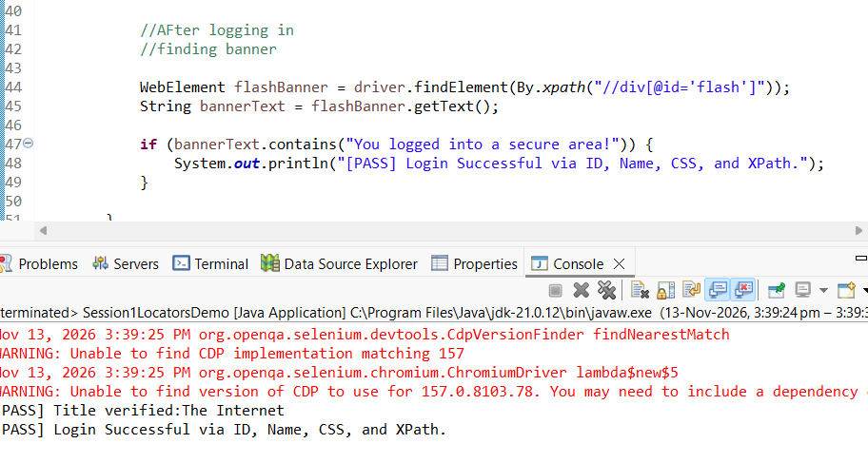

driver.manage().timeouts().implicitlyWait(Duration.ofSeconds(5)) tells Selenium to poll the DOM for up to 5 seconds when trying to find any element that is not immediately present. Note that in your specific snippet, driver.getTitle() does not trigger this wait because implicit wait only applies to findElement() and findElements() calls, whereas driver.get() already waits for the initial page load to complete.

1. How Implicit Wait Works in Your Snippet
- Global Scope: Once set on driver, the 5-second timeout stays active for the entire lifespan of that WebDriver instance (until driver.quit()).
- Polling Behavior: If an element is found in 0.2 seconds, Selenium moves on immediately without waiting the remaining 4.8 seconds. It only waits the full 5 seconds before throwing a NoSuchElementException.
- Why getTitle() ignores it: getTitle() reads the browser's current document title directly and does not search the DOM for a WebElement.

2. Practical & Real-Time Test Automation Examples
Example 1: Login Flow with Flash Message Validation (Using Your Page)
On the-internet.herokuapp.com/login, after clicking Login with tomsmith and SuperSecretPassword!, the page reloads or dynamically injects the #flash banner. Implicit wait gives Selenium a buffer to locate the banner without crashing: [1]
java
WebDriver driver = new ChromeDriver();
// Set once after initializing the driver
driver.manage().timeouts().implicitlyWait(Duration.ofSeconds(5));

driver.get("https://the-internet.herokuapp.com/login");

// Each findElement call automatically gets up to 5 seconds if the DOM is still rendering
driver.findElement(By.id("username")).sendKeys("tomsmith");
driver.findElement(By.id("password")).sendKeys("SuperSecretPassword!");
driver.findElement(By.cssSelector("button[type='submit']")).click();

// Waits up to 5 seconds for the success/error flash banner to appear in the DOM
WebElement flashBanner = driver.findElement(By.id("flash"));
System.out.println("Banner text: " + flashBanner.getText());
Use code with caution.
Example 2: Single-Page Applications (React, Angular, Vue)
In modern SPAs, clicking a navigation tab (like "Orders" or "Profile") fetches data via an API and injects new HTML elements a second or two later. An implicit wait handles these minor network and rendering delays across all pages without sprinkling Thread.sleep() throughout your test scripts.
Example 3: Asserting an Element Does Not Exist (Watch Out)
If you verify that an error banner disappeared using driver.findElements(By.id("flash")).isEmpty(), Selenium will still wait the full 5 seconds before returning an empty list. In large test suites with many negative checks, a high implicit wait (e.g., 15–30 seconds) slows down execution significantly.

3. Implicit Wait vs. Explicit Wait (When to Use Which)
Feature | Implicit Wait (implicitlyWait) | Explicit Wait (WebDriverWait)
Scope | Applied globally to every findElement / findElements call. | Applied to one specific element and condition.
What it Checks | Only checks if the element exists in the DOM (not if it is visible or clickable). | Checks specific states like elementToBeClickable, visibilityOf, or invisibilityOf.
Best Use Case | Small baseline buffer (2–5 seconds) for general DOM rendering delays. | Slow API calls, spinners/loaders disappearing, alerts, or elements that exist in the DOM but are hidden.
Golden Rule | Never mix high implicit waits with explicit waits in the same test, as their timeouts can stack unpredictably. | Set implicit wait to 0 (or keep it very low like 2–3s) when relying on WebDriverWait.

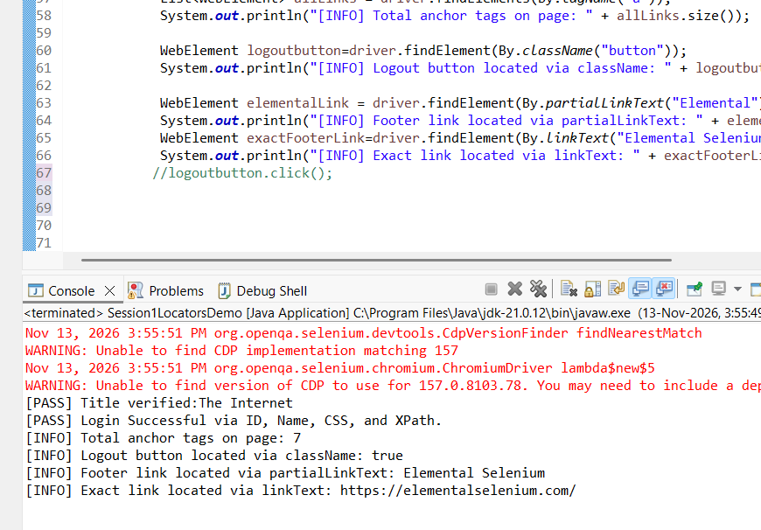
Different methods to retrieve from the web

1. Element Inspection Methods: Parameters, Return Types & Usage
Method Signature | Parameter(s) | Return Type | How It Works & Real-Time SDET Usage
getText() | None | String | Retrieves the visible, rendered inner text between opening and closing HTML tags (e.g., <a>Elemental Selenium</a> returns "Elemental Selenium"), stripping leading/trailing whitespace. Returns an empty string "" if the element is hidden via CSS (display: none) or is an <input> box.
getDomAttribute(String name) (New in Selenium 4) | name: The exact HTML attribute name in markup (e.g., "href", "placeholder", "id", "disabled"). | String (or null if missing) | Reads the static initial value written in the HTML source code. For boolean attributes like disabled or checked, it returns "true" if present in the HTML tag, or null if absent. Use this when verifying static links (href), image sources (src), or tooltip titles (title).
getDomProperty(String name) (New in Selenium 4) | name: The JavaScript DOM property name (e.g., "value", "checked", "textContent", "innerText"). | String (or null if unset) | Reads the live, dynamic runtime state of the element in the browser's DOM memory. Essential for reading text typed into an <input> box (getDomProperty("value")), checking live checkbox states (getDomProperty("checked")), or extracting hidden text (getDomProperty("textContent")).
getAttribute(String name) (Legacy / Deprecated in 4.27) | name: Attribute or property name. | String (or null) | Ambiguously checks the JS property first and falls back to the HTML attribute, injecting a large JavaScript atom under the hood. Replace this with getDomAttribute() or getDomProperty() in modern frameworks.
isDisplayed() | None | boolean | Verifies whether the element is currently visible on the viewport (not hidden by CSS). Used before clicking or asserting UI visibility.
isEnabled() | None | boolean | Returns false if a button or input has the disabled state; true otherwise. Used to validate form gating logic (e.g., "Submit button stays disabled until mandatory fields are filled").
isSelected() | None | boolean | Returns true if a checkbox, radio button, or <option> is currently selected.
getTagName() | None | String | Returns the lowercase HTML tag name (e.g., "a", "input", "button"), useful in generic helper utilities.
getCssValue(String propertyName) | propertyName: CSS style property (e.g., "color", "background-color", "font-size"). | String | Returns the computed CSS value (colors are normalized to rgba(...)). Used to verify error highlight colors (e.g., red border on invalid input).

Yes—we already covered all 8 locators, driver.get(), driver.manage().window().maximize(), sendKeys(), and click() in our earlier example.

The only genuinely new, critical concepts in this Session-2 breakdown that we haven't explicitly demonstrated yet are:

- findElement() vs. findElements() exception/return behavior (NoSuchElementException vs. an empty List<WebElement> of size 0).

- Using className and tagName specifically to capture groups of elements (such as counting all images <img> or iterating over header links) rather than targeting a single element.

- HTML Anatomy (<tag attribute="value">) mapped directly to how Selenium parses the DOM.

What Is New Here: findElement() vs. findElements() in Real-Time SDET Work
Feature | driver.findElement(By) | driver.findElements(By)
Return Type | Single WebElement (returns the first match if multiple exist in the DOM) | List<WebElement> (returns all matching elements in DOM order)
When 0 Elements Match | Throws NoSuchElementException immediately (after implicit wait expires) and halts the test | Returns an empty list (size() == 0) without throwing any exception
Real-Time SDET Usage | Interacting with mandatory UI controls (login inputs, submit buttons) where absence is a test failure | Negative assertions (verifying a deleted row or error banner is not present via list.isEmpty()) and bulk audits (checking for broken images or counting table rows)
Practical Delta Implementation (Screenshot-Ready for Session-2 Proof)
Instead of repeating the login flow, this script specifically demonstrates the new Session-2 behaviors: grouping elements via tagName and className, iterating through a List<WebElement>, and proving the NoSuchElementException vs. empty list (size == 0) difference.

Java
package com.automation.basics;

import java.time.Duration;
import java.util.List;
import org.openqa.selenium.By;
import org.openqa.selenium.NoSuchElementException;
import org.openqa.selenium.WebDriver;
import org.openqa.selenium.WebElement;
import org.openqa.selenium.chrome.ChromeDriver;

public class Session2FindElementsProof {

public static void main(String[] args) {
WebDriver driver = new ChromeDriver();
driver.manage().window().maximize();
driver.manage().timeouts().implicitlyWait(Duration.ofSeconds(3));

try {
driver.get("https://the-internet.herokuapp.com/");

List<WebElement> allLinks = driver.findElements(By.tagName("a"));
System.out.println("[GROUP - tagName] Total links found: " + allLinks.size());

List<WebElement> allHeadings = driver.findElements(By.className("heading"));
for (WebElement heading : allHeadings) {
System.out.println("[GROUP - className] Heading text: " + heading.getText());
}

List<WebElement> nonExistentList = driver.findElements(By.id("non-existent-id-999"));
System.out.println("[BEHAVIOR - findElements] Missing element list size: " + nonExistentList.size());

try {
driver.findElement(By.id("non-existent-id-999"));
} catch (NoSuchElementException e) {
System.out.println("[BEHAVIOR - findElement] Caught expected NoSuchElementException!");
}

} finally {
driver.quit();
}
}
}
What to Screenshot for Your Session-2 Word Doc
Capture the console output showing all four lines together:

- [GROUP - tagName] Total links found: 46

- [GROUP - className] Heading text: Welcome to the-internet

- [BEHAVIOR - findElements] Missing element list size: 0

- [BEHAVIOR - findElement] Caught expected NoSuchElementException!

